Dear Parent,
Kindly, quote this reference in future correspondence
NGDS-SGPP-2025-
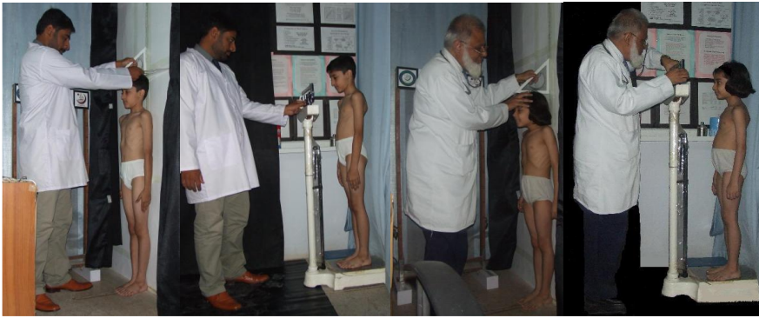
Meritorious Professor Dr. Syed Arif Kamal, Ex-Dean, Faculty of Science, University of Karachi, undertook the NGDS Pilot Project to establish “National Growth and Developmental Standards for the Pakistani Children” [The NGDS Pilot Project URL: https://ngds-ku.org • e-mail: profdrakamal@gmail.com • paper mail: The NGDS Pilot Project, PO Box 8423, University of Karachi, Karachi 75270] under the directives of Governor Sindh/Chancellor, University of Karachi — a goodwill and a public-service endeavor conducted for the care and the development of young persons to prepare them mentally, physically and emotionally for rewarding careers in the civil and the military services. This project is being conducted, successfully, since 1998 — over 2500 students measured and methods developed to determine detailed growth-and-obesity roadmaps. Trainings were imparted to research groups in Pakistan and abroad. In this connection, periodic measurements of height, mass as well as circumferences of chest, hip, mid-upper-arm and waist of your child shall be obtained as part of anthropometric study of NGDS Pilot Project/SGPP. In addition, a general checkup shall be conducted including detailed examination for scoliosis (a body-disfiguring disease, which develops silently in the child, damaging vital organs, heart, lungs, etc.). You will receive Growth-and-Obesity Profile 4.5 of your child, which’ll give percentile-of-height/ mass, estimated-adult height/mass (to find out at a very young age if your child is qualifying for induction in the Armed Forces of Pakistan or not and suggestions to overcome this deficiency) and estimated-adult-obesity profile (you’ll get a chance to discuss all of these with the Project Director, physically or via ZOOM meeting).
a
b
c
d

Fig. NGDS-1a-d. Measurement of (a) boy’s height; (b) boy’s mass; (c) girl’s height; (d) girl’s mass
————————————————————————————————————————————————————————————————————————————————
The data obtained may be reported in research papers in collective form. The NGDS Pilot Project Website has photographs of procedures and reading material https://ngds-ku.org. As per international standards (as well as those of the Armed Forces of Pakistan), your child shall be measured wearing only short underpants, all clothing above the waist removed (Fig. NGDS-1a-d), so that accurate and precise measurements are obtained.
Kindly, fill in the following slip and return to Growth-and-Imaging Laboratory before the measurement session.

Version 3.00 (2025-04-12) Project Director
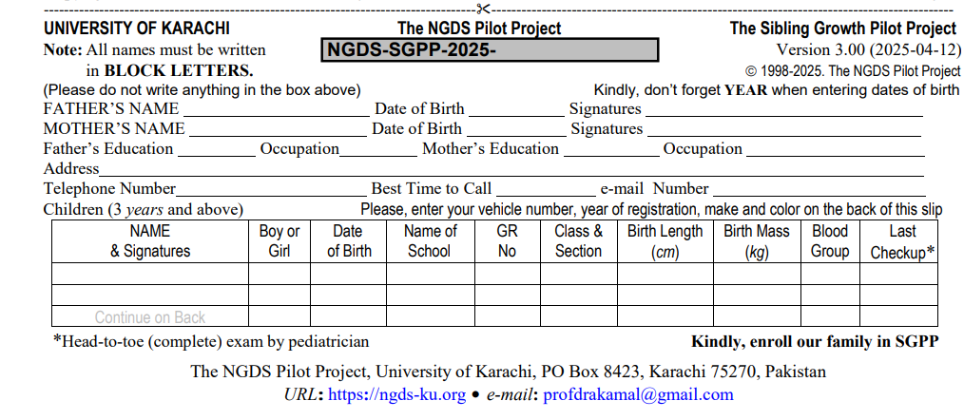
Copyright 1998-2025. The NGDS Pilot Project The NGDS Pilot Project

Recommended Clothing
I N S T R U C T I O N S

11+ Children: Athletic kit OR T-shirt, trousers (boys); shalwaar kameez (girls)

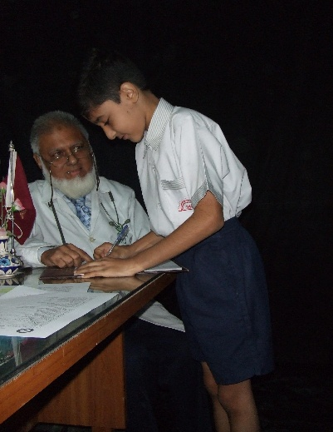
a
b

Fig. NGDS-2a, b. Under-11 children reporting in school uniform; girl’s hair open, held only by hairband
————————————————————————————————————————————————————————————————————————————————
Under-11 Children: School Uniform (Fig. NGDS-2a, b) OR
Boys — T-shirt (absolutely nothing under T-shirt), shorts (younger)/trousers (older), white briefs of the format given in Fig. NGDS-1a, b, socks and (old) polished shoes
Girls — T-shirt (absolutely nothing under T-shirt), skirt OR dress/frock (absolutely nothing under frock), white panties of the format given in Fig. NGDS-1c, d, socks and (old) polished shoes

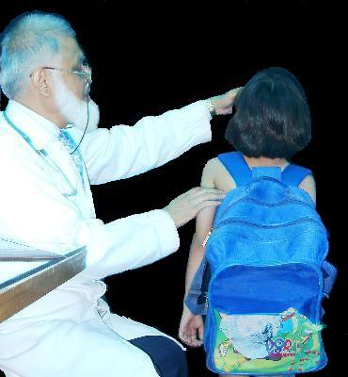
DOs for Parents
a) Both parents must come during the first checkup.
b) Brief your children about the checkup before coming.
c) Bring only those children, whose checkups are scheduled.

DOs for Children
a) Good night’s sleep before check up
b) Remove all body marks
c) Nails TRIMMED and CLEAN
d) Teeth BRUSHED
e) Shower in the morning
f) Bring in SCHOOL BAG with books (Fig. NGDS-3)
g) GIRLS: Leave hair open, using only HAIRBAND

DO NOTs for Children
a) DO NOT wear slippers, wear OLD SHOES
b) NOTHING BY MOUTH one hour before checkup time
c) No CHAIN, No JWELERY
d) GIRLS: No NAIL POLISH, No MEHNDI
e) GIRLS: No BRAIDING of hair, No HAIRCLIPS, No HAIRPINS
Fig. NGDS-3. Proper wearing of school bag
————————————————————————————————
NOTES
Your children must be free from COLDS, FEVER, ACHES, RASHES, etc. on the day of checkup. If such a thing appears, please contact the SGPP Team, immediately, to re-schedule the appointment.
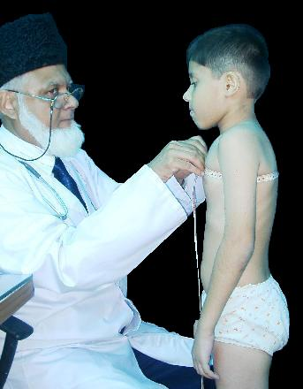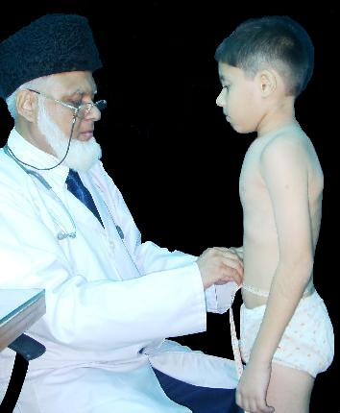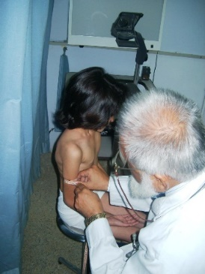

Fig. NGDS-4a, b. Measurements of (a) chest, (b) waist and (c) mid-upper-arm circumferences
——————————————————————————————————————————————————————————————————————————————
More pictures of anthropometry: https://www.ngds-ku.org/photos1/photos.htm
Sample Growth-and-Obesity Profile 4.5: https://www.ngds-ku.org/Papers/C146/ZHZ_Profile4.5.pdf
Web address of this document: https://www.ngds-ku.org/SGPP/Form.pdf
a
b
c

